**Cumulative Project: Gold Medal Metrics**

**Create the SQL queries to power an Olympics analytics web app.**

**Gold Medal Metrics**

**Project Overview**

In this project you will be writing all the SQL statements for an Olympic metrics reporting web application called Gold Medal Metrics.

Gold Medal Metrics allows users to:

* View countries in a list with their population, GDP, and number of Olympic gold medals.
* Sort the list of countries by any of these attributes, as well as alphabetically by name.
* View a detailed description of a country, with statistics on their Olympic wins.
* View a list of every Olympic win a country has with the year, season, winner name, city, and event.
* Sort the list of Olympic wins by any of these attributes.

You can view all of this functionality in action in the video below:

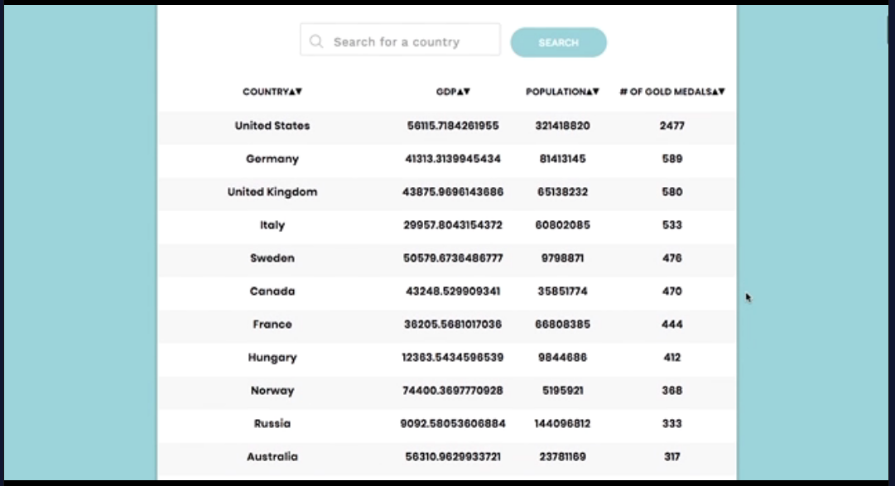

**How To Begin**

To start, download the starting code for this project [here](https://content.codecademy.com/PRO/skill-paths/backend-javascript/projects/gold-medal-metrics/project-5-gold-medal-metrics-start.zip). After downloading the zip folder, double click it to uncompress it and access the contents of this project.

To view the webpage, run npm install and then npm run webpack to compile the front-end files, and follow that with open index.html from the root directory of this project. To start your server, run node server.js. Refresh your browser to collect the information from the server. Every time you change **server.js**, you will have to restart your server before the changes will take effect. To do this press “control + c” in the bash terminal where your server is running (or close the terminal) to shut it down and then re-run node server.js to start it again. While your server is running, you will not be able to run commands in the bash terminal, so open a new terminal if you want to run other commands.

**Implementation Details**

To complete this project, you will need to write a series of JavaScript functions that return the SQL queries that operate Gold Medal Metrics. The functions themselves are stubbed out in **sql.js** with comments about the query each should return. Below we list the different functions and the expected returned query.

**Gold Medal Metric Functions**

**createCountryTable**

Returns the SQL command that will create a table, named Country with the following columns:

* name a required text field.
* code a required text field.
* gdp an integer.
* population an integer.

**createGoldMedalTable**

Returns the SQL command that will create a table, named GoldMedal with the following columns:

* id an integer that will function as the primary key.
* year a required integer.
* city a required text field.
* season a required text field.
* name a required text field.
* country a required text field.
* gender a required text field.
* sport a required text field.
* discipline a required text field.
* event a required text field.

**goldMedalNumber**

Takes an argument, the name of a country. Returns the SQL command that will retrieve the number of gold medals that country has won in all Olympic games, aliased to the name count.

**mostSummerWins**

Takes an argument, the name of a country. Returns the SQL command that will retrieve the year that the county has won the most gold medals (only in Summer games), and how many medals were won, aliased to the name count.

**mostWinterWins**

Takes an argument, the name of a country. Returns the SQL command that will retrieve the year that the county has won the most gold medals (only in Winter games), and how many medals were won, aliased to the name count.

**bestYear**

Takes an argument, the name of a country. Returns the SQL command that will retrieve the year that country won the most Olympic gold medals, and how many medals were won, aliased to the name count.

**bestDiscipline**

Takes an argument, the name of a country. Returns the SQL command that will retrieve the discipline in which that country won the most Olympic gold medals, and how many medals were won, aliased to the name count.

**bestSport**

Takes an argument, the name of a country. Returns the SQL command that will retrieve the sport in which that country won the most Olympic gold medals, and how many medals were won, aliased to the name count.

**bestEvent**

Takes an argument, the name of a country. Returns the SQL command that will retrieve the event in which that country won the most Olympic gold medals, and how many medals were won, aliased to the name count.

**numberMenMedalists**

Takes an argument, the name of a country. Returns the SQL command that will retrieve the number of men who have won Olympic gold medals for that country, aliased to the name count.

**numberWomenMedalists**

Takes an argument, the name of a country. Returns the SQL command that will retrieve the number of women who have won Olympic gold medals for that country, aliased to the name count.

**mostMedaledAthlete**

Takes an argument, the name of a country. returns the sql command that will retrieve the name of the athlete who won Olympic gold medals for that country, aliased to the name count.

**orderedMedals**

Takes three arguments, the name of the country and, optionally, a field to sort the results by and a boolean representing the direction the sort should go in. This function should return a SQL query that returns all fields for every Olympic gold medal won by the given country. When the field argument is present, the function should return a SQL query that orders the results by that field – ascending if the direction is true and descending if the direction is false.

**Bonus: orderedSports**

Takes three arguments, the name of the country and, optionally, a field to sort the results by and a boolean representing the direction the sort should go in. This function should return a SQL query that retrieves all the sports that country has received a Gold Medal in, additionally the query returned should return the number of times the given country received a medal in that sport, aliased to the name count, furthermore the query should calculate, as a percentage, how much of the country’s Olympic gold medals were in that sport, aliased to the name ‘percent’. When the field argument is present, the function should return a SQL query that orders the results by that field – ascending if the direction is true and descending if the direction is false.

**Testing**

A testing suite has been provided for you, checking for all essential functionality and edge cases.

To run these tests, first, open the root project directory in your terminal. Then run npm install to install all necessary testing dependencies (if you haven’t already). Finally, run npm test. You will see a list of tests that ran with information about whether or not each test passed. After this list, you will see more specific output about why each failing test failed.

As you implement functionality, run the tests to ensure you are creating correctly named variables and functions that return the proper values. The tests will additionally help you identify edge cases that you may not have anticipated when first writing the functions.

______________________________________________________________________________

**Cumulative Project: Gold Medal Metrics Solution**

**Codecademy solution for Gold Medal Metrics**

You can download the solution code to Gold Medal Metrics [here](https://content.codecademy.com/PRO/skill-paths/backend-javascript/projects/gold-medal-metrics/project-5-gold-medal-metrics-solution.zip).

Try not to rely on the solution code until you’ve completed the project, or if you’re feeling stuck and your work has become unproductive. Remember that our solution is just *one* way to complete the Gold Medal Metrics project, and you may have come up with a very different implementation. The important thing is that your code achieves the desired result, not that it looks exactly like ours. There is usually no single “right answer” in a coding problem, and there’s almost always room for improvement!